

1. 8 Puzzle Problem

Aim
To solve the 8-Puzzle problem using the A* Search algorithm in Python.

Algorithm
- Define the initial state and goal state of the puzzle.
- Calculate the heuristic value (number of misplaced tiles).
- Generate all possible moves (up, down, left, and right).
- Select the state with the lowest cost using the A* search algorithm.
- Repeat the process until the goal state is reached.
- Display the sequence of moves from the initial state to the goal state.

Program
from queue import PriorityQueue

goal = [[1,2,3],
[4,5,6],
[7,8,0]]

def heuristic(state):
count = 0
for i in range(3):
for j in range(3):
if state[i][j] != 0 and state[i][j] != goal[i][j]:
count += 1
return count

def find_blank(state):
for i in range(3):
for j in range(3):
if state[i][j] == 0:
return i, j

def copy(state):
return [row[:] for row in state]

def neighbors(state):
x, y = find_blank(state)
moves = [(1,0),(-1,0),(0,1),(0,-1)]
result = []

for dx, dy in moves:
nx, ny = x+dx, y+dy
if 0 <= nx < 3 and 0 <= ny < 3:
new = copy(state)
new[x][y], new[nx][ny] = new[nx][ny], new[x][y]
result.append(new)
return result

start = [[1,2,3],
[4,0,6],
[7,5,8]]

pq = PriorityQueue()
pq.put((heuristic(start), start))
visited = []

while not pq.empty():
h, state = pq.get()

if state == goal:
print("Goal State Reached")
for row in state:
print(row)
break

if state not in visited:
visited.append(state)
for next_state in neighbors(state):
if next_state not in visited:
pq.put((heuristic(next_state), next_state))

Input
Initial State

1 2 3
4 0 6
7 5 8

Output
Goal State Reached

[1, 2, 3]
[4, 5, 6]
[7, 8, 0]

Result
Thus, the 8-Puzzle problem was solved successfully using the A Search algorithm in Python.
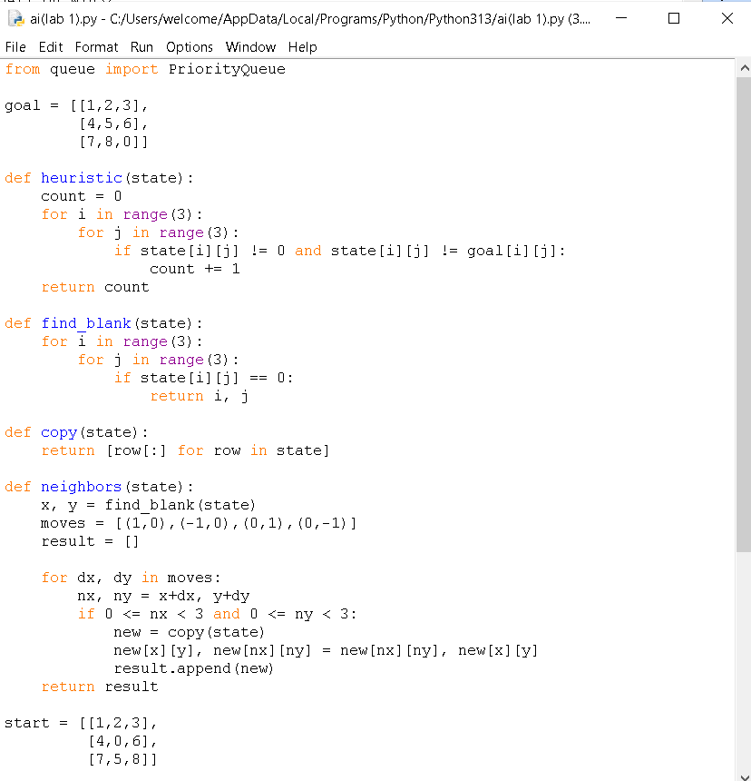

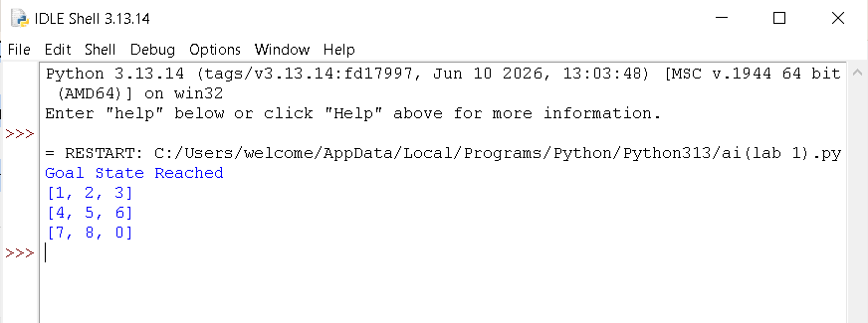

2. 8 Queen Problem

Aim
To develop a Python program to solve the 8-Queen Problem using the Backtracking Algorithm by placing eight queens on an 8×8 chessboard such that no two queens attack each other.

Algorithm
- Create an empty 8×8 chessboard.
- Start placing queens from the first row.
- Check whether the current position is safe:
  - No queen in the same column.
  - No queen in the left diagonal.
  - No queen in the right diagonal.
- If the position is safe, place the queen.
- Recursively place queens in the next row.
- If no safe position exists, backtrack and try another column.
- Repeat until all eight queens are placed.
- Display the final chessboard arrangement.

Program
N = 8

def is_safe(board, row, col):
for i in range(row):
if board[i] == col:
return False
if abs(board[i] - col) == abs(i - row):
return False
return True

def solve(board, row):
if row == N:
return True

for col in range(N):
if is_safe(board, row, col):
board[row] = col
if solve(board, row + 1):
return True
board[row] = -1
return False

board = [-1] * N

if solve(board, 0):
print("Solution:")
for i in range(N):
for j in range(N):
if board[i] == j:
print("Q", end=" ")
else:
print(".", end=" ")
print()
else:
print("No Solution Exists")

Input
No input is required.

Output
Solution:

Q . . . . . . .
. . . . Q . . .
. . . . . . . Q
. . . . . Q . .
. . Q . . . . .
. . . . . . Q .
. Q . . . . . .
. . . Q . . . .

Result
Thus, the 8-Queen Problem was solved successfully using the Backtracking Algorithm in Python.

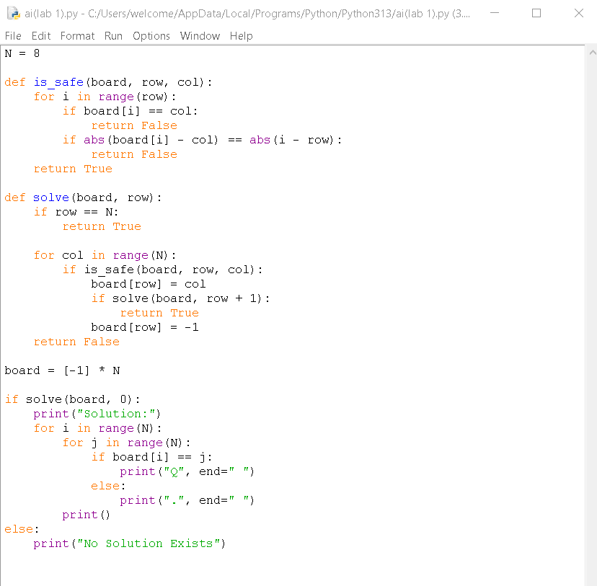

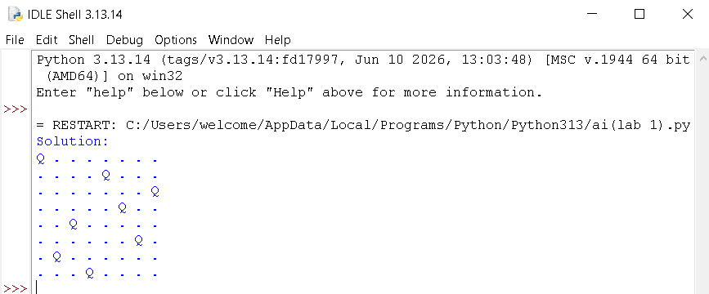

3. Water Jug Problem

Aim
To write a Python program to solve the Water Jug Problem using the Breadth-First Search (BFS) algorithm to obtain the required quantity of water.

Algorithm
- Start with both jugs empty.
- Represent each state as (Jug1, Jug2).
- Use a queue to store the states to be explored.
- Generate all possible operations:
  - Fill Jug 1.
  - Fill Jug 2.
  - Empty Jug 1.
  - Empty Jug 2.
  - Pour water from Jug 1 to Jug 2.
  - Pour water from Jug 2 to Jug 1.
- Mark each visited state to avoid repetition.
- Repeat until the target amount of water is obtained.
- Display the sequence of states and the final solution.

Program
from collections import deque

def water_jug(jug1, jug2, target):
visited = set()
queue = deque([(0, 0)])

while queue:
x, y = queue.popleft()

if (x, y) in visited:
continue

visited.add((x, y))
print((x, y))

if x == target or y == target:
print("Target Reached")
return

# Fill either jug
queue.append((jug1, y))
queue.append((x, jug2))

# Empty either jug
queue.append((0, y))
queue.append((x, 0))

# Pour Jug1 -> Jug2
t = min(x, jug2 - y)
queue.append((x - t, y + t))

# Pour Jug2 -> Jug1
t = min(y, jug1 - x)
queue.append((x + t, y - t))

water_jug(4, 3, 2)

Input
Capacity of Jug 1 = 4 litres
Capacity of Jug 2 = 3 litres
Target = 2 litres

Output
(0, 0)
(4, 0)
(0, 3)
(1, 3)
(3, 0)
(1, 0)
(3, 3)
(0, 1)
(4, 2)
Target Reached

Result
Thus, the Water Jug Problem was implemented successfully in Python, and the required 2 litres of water was obtained

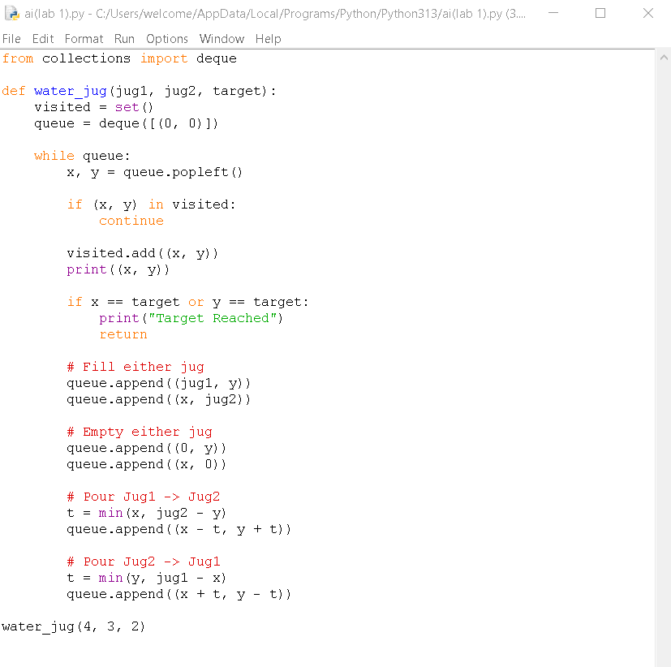
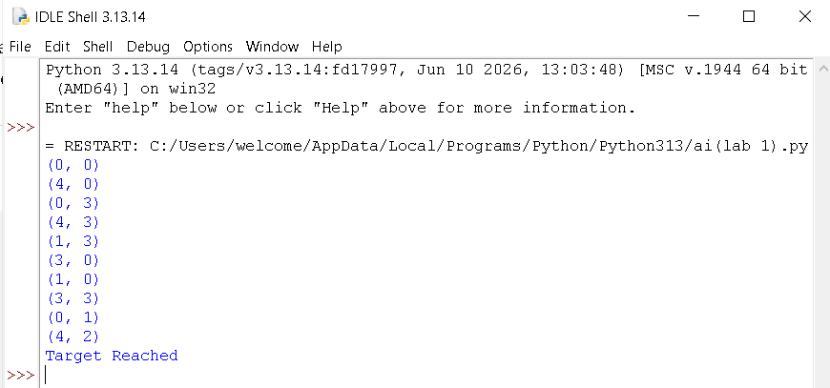

4. Crypt Arithmetic Problem

Aim
To write a Python program to solve the Crypt Arithmetic Problem by assigning unique digits to letters so that the given arithmetic equation is satisfied.

Algorithm
- Define the words in the crypt arithmetic problem
- Assign unique digits (0–9) to each letter.
- Ensure that the leading letters are not assigned zero.
- Convert the words into numbers.
- Check whether the arithmetic equation is satisfied.
- If a valid assignment is found, display the solution.
- Stop the program.

Program
from itertools import permutations

letters = ('S', 'E', 'N', 'D', 'M', 'O', 'R', 'Y')

for p in permutations(range(10), 8):
d = dict(zip(letters, p))

if d['S'] == 0 or d['M'] == 0:
continue

SEND = 1000*d['S'] + 100*d['E'] + 10*d['N'] + d['D']
MORE = 1000*d['M'] + 100*d['O'] + 10*d['R'] + d['E']
MONEY = 10000*d['M'] + 1000*d['O'] + 100*d['N'] + 10*d['E'] + d['Y']

if SEND + MORE == MONEY:
print("Solution:")
print(d)
print(SEND, "+", MORE, "=", MONEY)
break

Input
No input is required.

Output
Solution:
{'S': 9, 'E': 5, 'N': 6, 'D': 7,
'M': 1, 'O': 0, 'R': 8, 'Y': 2}

9567 + 1085 = 10652

Result
Thus, the Crypt Arithmetic Problem was solved successfully using Python by assigning unique digits to letters that satisfy the given arithmetic expression.
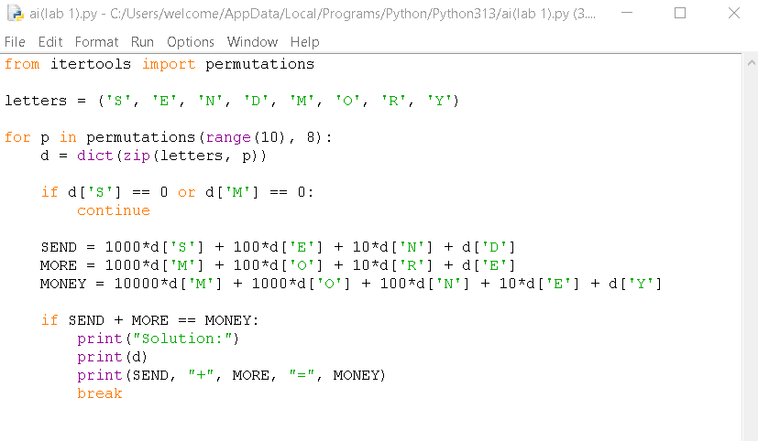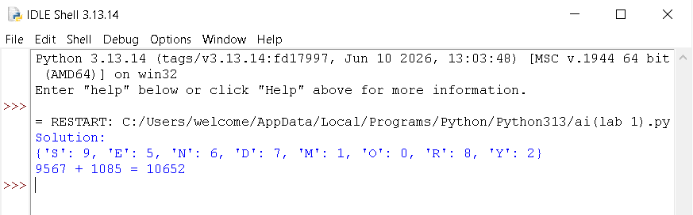

5. Missionaries and Cannibals Problem

Aim
To write a Python program to solve the Missionaries and Cannibals Problem using Breadth-First Search (BFS).

Algorithm
- Represent the initial state as (3 Missionaries, 3 Cannibals, Left Bank).
- Represent the goal state as (0 Missionaries, 0 Cannibals, Right Bank).
- Define all possible boat moves.
- Generate valid successor states.
- Ensure missionaries are never outnumbered by cannibals on either bank.
- Use BFS to explore all valid states.
- Stop when the goal state is reached and display the solution.

Program
from collections import deque

def is_valid(m, c):
if m < 0 or c < 0 or m > 3 or c > 3:
return False
if (m > 0 and m < c):
return False
if (3 - m > 0 and 3 - m < 3 - c):
return False
return True

def missionaries_cannibals():
start = (3, 3, 'L')
goal = (0, 0, 'R')

moves = [(1,0),(2,0),(0,1),(0,2),(1,1)]

queue = deque([start])
visited = set()

while queue:
state = queue.popleft()

if state in visited:
continue

visited.add(state)
print(state)
if state == goal:
print("Goal Reached")
return

m, c, side = state

for dm, dc in moves:
if side == 'L':
nm, nc = m-dm, c-dc
ns = 'R'
else:
nm, nc = m+dm, c+dc
ns = 'L'

if is_valid(nm, nc):
queue.append((nm, nc, ns))

missionaries_cannibals()

Input
No input is required.

Output
(3, 3, 'L')
(3, 2, 'R')
(3, 1, 'L')
...
(0, 0, 'R')
Goal Reached

Result
Thus, the Missionaries and Cannibals Problem was solved successfully using the Breadth-First Search (BFS) algorithm in Python.

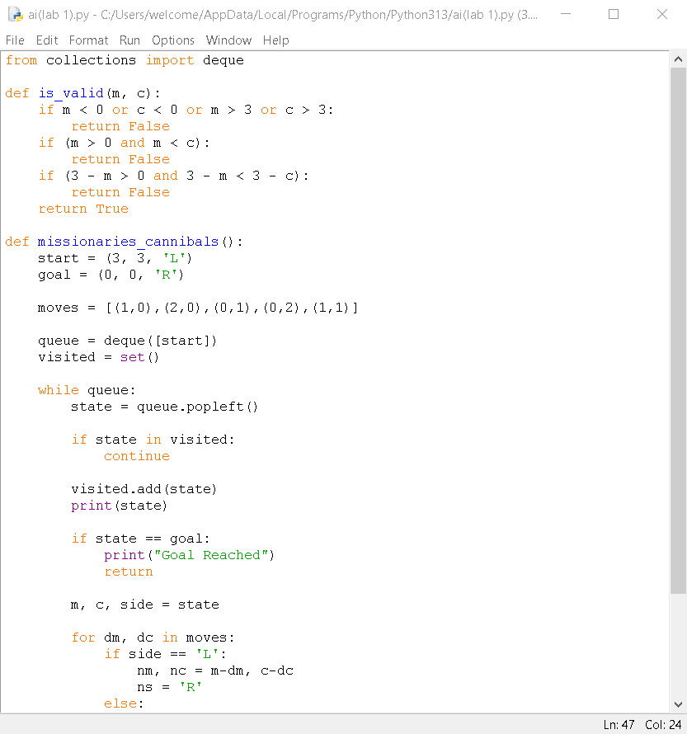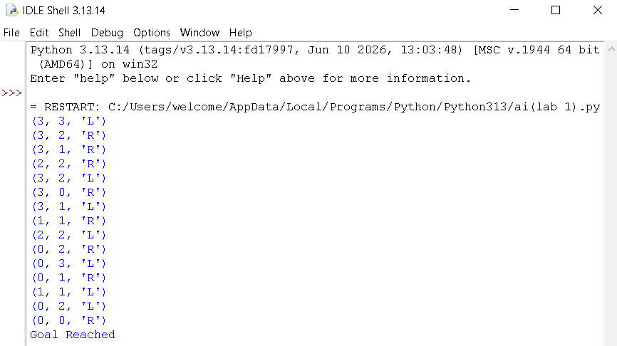

6. Vacuum Cleaner Problem

Aim
To write a Python program to simulate a Vacuum Cleaner Agent that cleans all dirty rooms.

Algorithm
- Initialize the rooms and their status (Dirty/Clean).
- Start from the first room.
- Check the status of the current room.
- If the room is dirty, clean it.
- Move to the next room.
- Repeat until all rooms are clean.
- Display the final status of all rooms.

Program
rooms = {'A': 'Dirty', 'B': 'Dirty'}

for room in rooms:
print("Current Room:", room)

if rooms[room] == "Dirty":
print("Cleaning", room)
rooms[room] = "Clean"

print(room, ":", rooms[room])

print("\nFinal Room Status:")
for room in rooms:
print(room, ":", rooms[room])

print("All rooms are clean.")

Input
Room A = Dirty
Room B = Dirty

Output
Current Room: A
Cleaning A
A : Clean

Current Room: B
Cleaning B
B : Clean

Final Room Status:
A : Clean
B : Clean

All rooms are clean.

Result
Thus, the Vacuum Cleaner Problem was implemented successfully in Python, and all dirty rooms were cleaned.

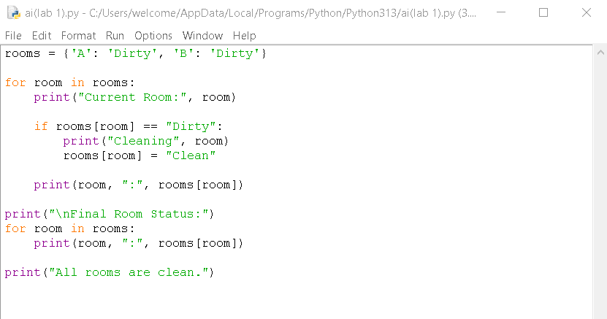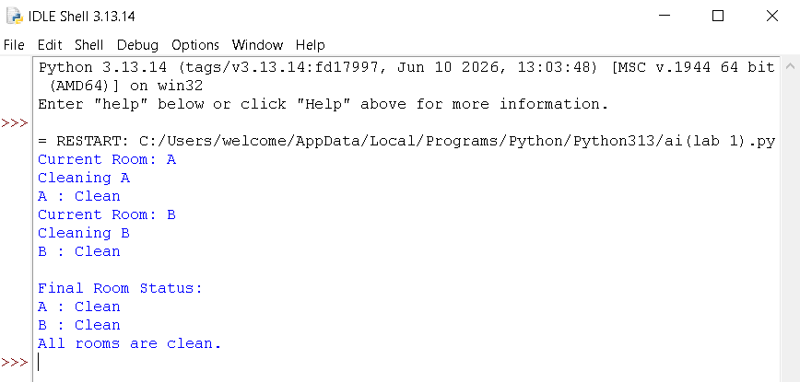

7. Breadth First Search (BFS)

Aim
To write a Python program to implement the Breadth First Search (BFS) algorithm for graph traversal.

Algorithm
- Start from the source node.
- Mark the source node as visited.
- Insert the source node into a queue.
- Remove a node from the queue.
- Display the node.
- Visit all unvisited adjacent nodes and insert them into the queue.
- Repeat until the queue becomes empty.

Program
from collections import deque

graph = {
'A': ['B', 'C'],
'B': ['D', 'E'],
'C': ['F'],
'D': [],
'E': ['F'],
'F': []
}

visited = set()

def bfs(start):
queue = deque([start])
visited.add(start)

while queue:
node = queue.popleft()
print(node, end=" ")

for neighbour in graph[node]:
if neighbour not in visited:
visited.add(neighbour)
queue.append(neighbour)

bfs('A')

Input
Starting Node:
A

Output
A B C D E F

Result
Thus, the Breadth First Search (BFS) algorithm was implemented successfully.

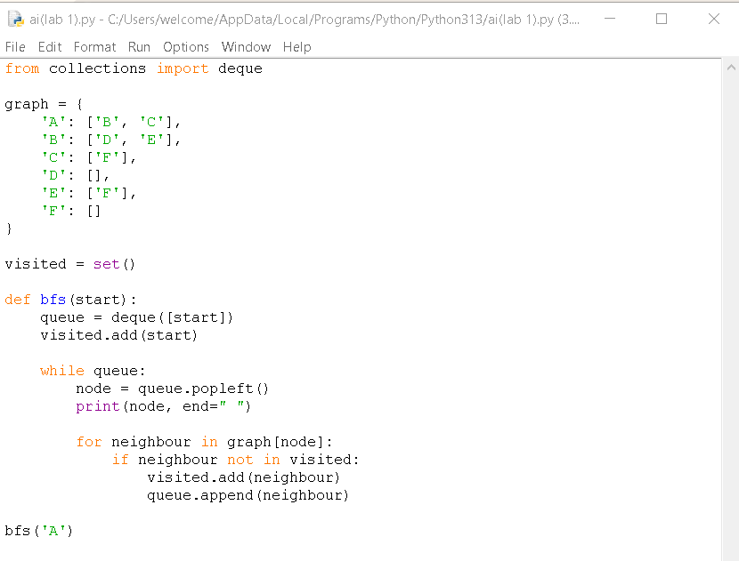

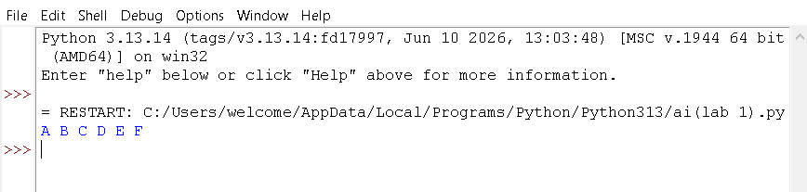

8. Depth First Search (DFS)

Aim
To write a Python program to implement the Depth First Search (DFS) algorithm for graph traversal.

Algorithm
- Start from the source node.
- Mark the node as visited.
- Display the node.
- Recursively visit all unvisited adjacent nodes.
- Continue until all nodes are visited.

Program
graph = {
'A': ['B', 'C'],
'B': ['D', 'E'],
'C': ['F'],
'D': [],
'E': ['F'],
'F': []
}

visited = set()

def dfs(node):
if node not in visited:
print(node, end=" ")
visited.add(node)

for neighbour in graph[node]:
dfs(neighbour)

dfs('A')

Input
Starting Node:
A

Output
A B D E F C

Result
Thus, the Depth First Search (DFS) algorithm was implemented successfully.
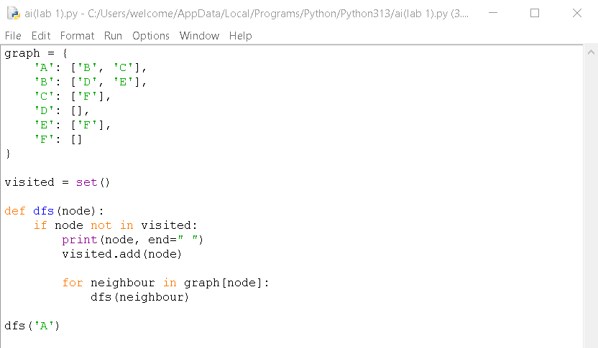

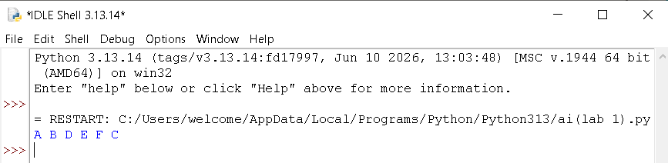

9. Travelling Salesman Problem (TSP)

Aim
To write a Python program to solve the Travelling Salesman Problem using brute force.

Algorithm
- Read the distance matrix.
- Generate all possible city permutations.
- Calculate the total distance for each route.
- Select the route with the minimum distance.
- Display the minimum cost.

Program
from itertools import permutations

graph = [
[0, 10, 15, 20],
[10, 0, 35, 25],
[15, 35, 0, 30],
[20, 25, 30, 0]
]

n = len(graph)
cities = range(1, n)

min_cost = float('inf')

for path in permutations(cities):
cost = 0
k = 0

for city in path:
cost += graph[k][city]
k = city

cost += graph[k][0]

if cost < min_cost:
min_cost = cost

print("Minimum Cost:", min_cost)

Input
Distance Matrix:
0 10 15 20
10 0 35 25
15 35 0 30
20 25 30 0

Output
Minimum Cost: 80

Result
Thus, the Travelling Salesman Problem was solved successfully using Python.

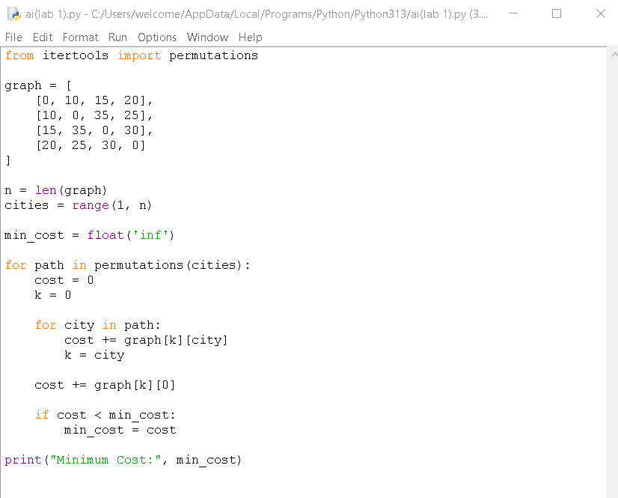

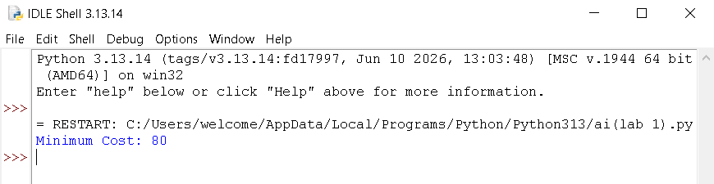

10. A (A-Star) Algorithm*

Aim
To write a Python program to implement the A* search algorithm.

Algorithm
- Initialize the open list with the start node.
- Maintain a closed list for visited nodes.
- Select the node with the lowest f = g + h value.
- If the goal node is reached, stop.
- Otherwise, expand the node and update the costs.
- Repeat until the goal is found.

Program
from queue import PriorityQueue

graph = {
'A': [('B', 1), ('C', 3)],
'B': [('D', 3), ('E', 6)],
'C': [('F', 5)],
'D': [],
'E': [('F', 2)],
'F': []
}

heuristic = {
'A': 6,
'B': 4,
'C': 4,
'D': 2,
'E': 1,
'F': 0
}

def astar(start, goal):
pq = PriorityQueue()
pq.put((0, start))
cost = {start: 0}

while not pq.empty():
_, node = pq.get()

if node == goal:
print("Goal Reached")
return

for neighbour, weight in graph[node]:
new_cost = cost[node] + weight

if neighbour not in cost or new_cost < cost[neighbour]:
cost[neighbour] = new_cost
priority = new_cost + heuristic[neighbour]
pq.put((priority, neighbour))

astar('A', 'F')

Input
Start Node:
A

Goal Node:
F

Output
Goal Reached

Result
Thus, the A* search algorithm was implemented successfully in Python.
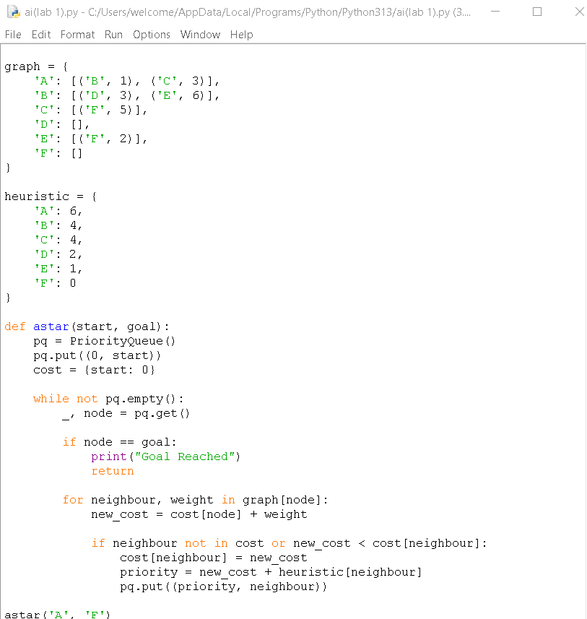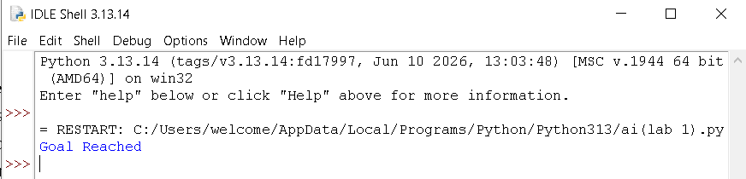

11. Map Coloring using CSP
Aim
To write a Python program to solve the Map Coloring Problem using Constraint Satisfaction Problem (CSP).
Algorithm
- Start with a set of regions and available colors.
- Represent each region as a variable.
- Assign a color to each region.
- Check whether the assigned color conflicts with neighboring regions.
- If there is no conflict, move to the next region.
- If a conflict occurs, backtrack and try another color.
- Repeat until all regions are colored.
- Display the final color assignment.
Program
def map_coloring():
regions = ['A', 'B', 'C', 'D']
neighbors = {
'A': ['B', 'C'],
'B': ['A', 'C', 'D'],
'C': ['A', 'B', 'D'],
'D': ['B', 'C']
}
colors = ['Red', 'Green', 'Blue']
assignment = {}
def is_valid(region, color):
for neighbor in neighbors[region]:
if neighbor in assignment and assignment[neighbor] == color:
return False
return True
def solve(index):
if index == len(regions):
return True
region = regions[index]
for color in colors:
if is_valid(region, color):
assignment[region] = color
if solve(index + 1):
return True
del assignment[region]
return False
if solve(0):
print("Map Coloring Solution:")
for region in regions:
print(region, ":", assignment[region])
else:
print("No solution found")
map_coloring()
Input
Regions = A, B, C, D
Colors = Red, Green, Blue
Output
Map Coloring Solution:
A : Red
B : Green
C : Blue
D : Red
Result
Thus, the Map Coloring Problem was implemented successfully in Python using the CSP backtracking algorithm.

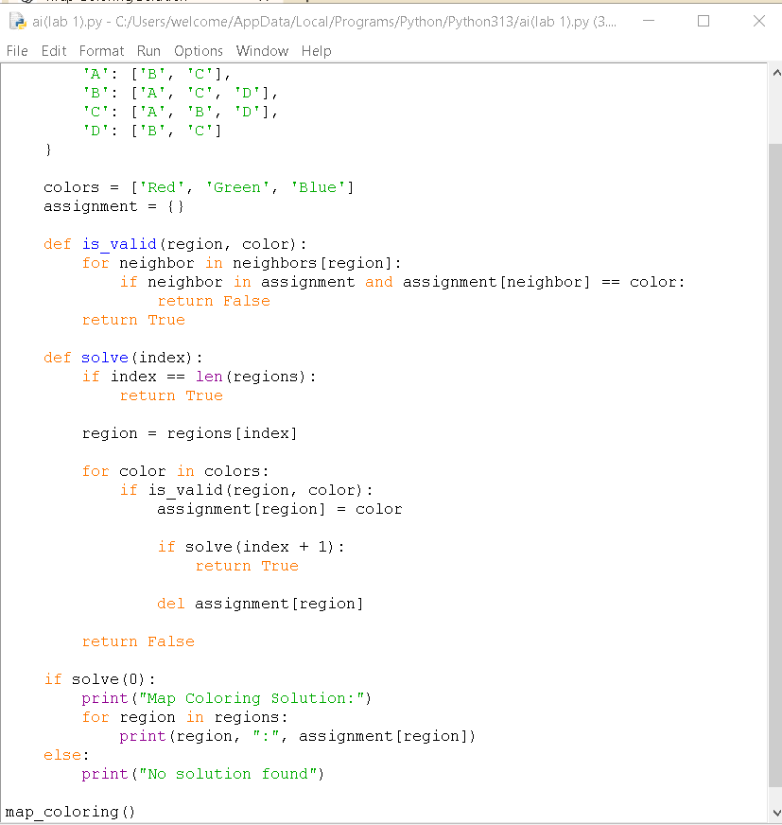

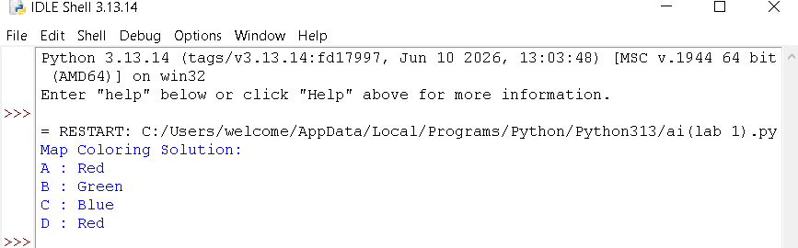
12. Tic Tac Toe Game
Aim
To write a Python program to implement a simple Tic Tac Toe game.
Algorithm
- Start with an empty 3 × 3 board.
- Display the board.
- Allow Player X to enter a position.
Program
def display(board):
print(board[0], "|", board[1], "|", board[2])
print("--+---+--")
print(board[3], "|", board[4], "|", board[5])
print("--+---+--")
print(board[6], "|", board[7], "|", board[8])
def check_winner(board, player):
wins = [
[0, 1, 2],
[3, 4, 5],
[6, 7, 8],
[0, 3, 6],
[1, 4, 7],
[2, 5, 8],
[0, 4, 8],
[2, 4, 6]
]

for w in wins:
if all(board[i] == player for i in w):
return True
return False
board = ['1', '2', '3', '4', '5', '6', '7', '8', '9']
player = 'X'
for turn in range(9):
display(board)
pos = int(input("Enter position: ")) - 1
if board[pos] in ['X', 'O']:
print("Position already occupied")
continue
board[pos] = player
if check_winner(board, player):
display(board)
print("Player", player, "wins")
break
player = 'O' if player == 'X' else 'X'
else:
display(board)
print("Game Draw")
Input
Enter position: 1
Enter position: 4
Enter position: 2
Enter position: 5
Enter position: 3
Output
X | X | X
--+---+--
O | O | 6
--+---+--
7 | 8 | 9

Player X wins
Result
Thus, the Tic Tac Toe game was implemented successfully in Python.

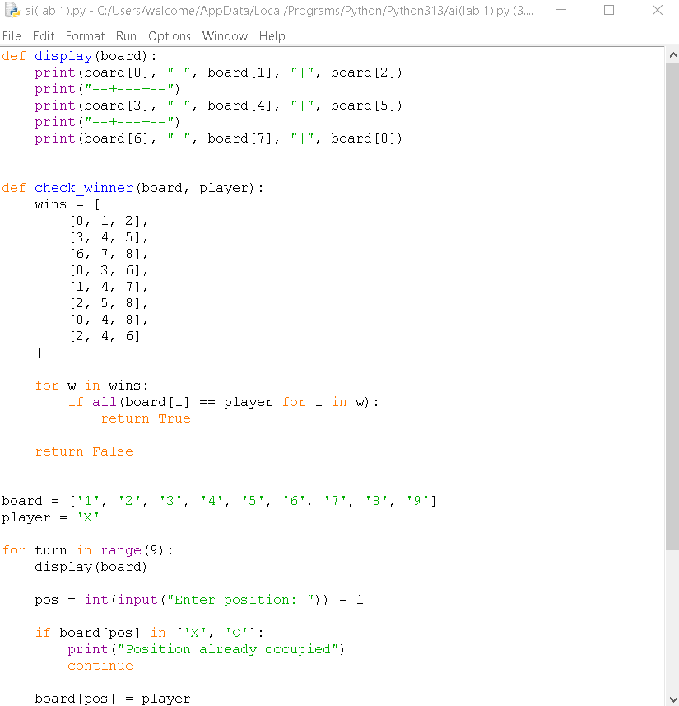

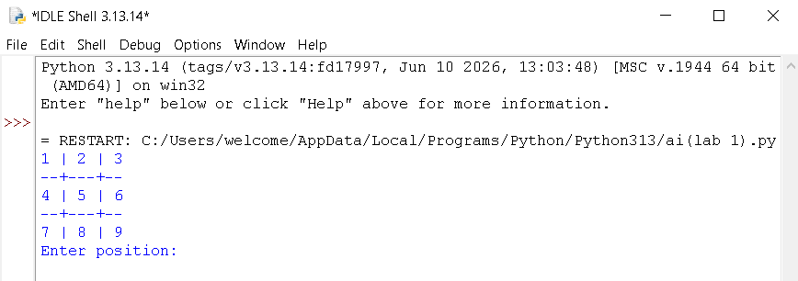

13. Minimax Algorithm for Gaming
Aim
To write a Python program to implement the Minimax Algorithm for gaming.
Algorithm
- Start with the current game state.
- Generate all possible moves.
- Check whether the state is a terminal state.
- Assign a score to the terminal state.
- The maximizing player selects the maximum score.
- The minimizing player selects the minimum score.
- Continue recursively until the best move is found.
- Display the best move.
Program
def minimax(depth, is_max):
scores = [10, 5, -10, 0]
if depth == 0:
return scores[0]
if is_max:
best = -1000
for i in range(2):
value = minimax(depth - 1, False)
best = max(best, value)
return best
else:
best = 1000
for i in range(2):
value = minimax(depth - 1, True)
best = min(best, value)
return best

print("Best Score:", minimax(3, True))
Input
Game depth = 3
Output
Best Score: 10
Result
Thus, the Minimax Algorithm was implemented successfully in Python for gaming.

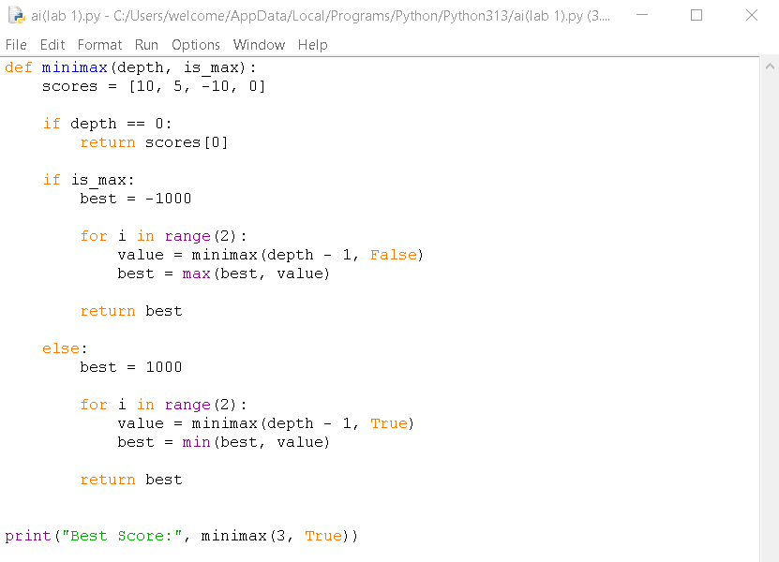

14. Alpha-Beta Pruning Algorithm for Gaming
Aim
To write a Python program to implement the Alpha-Beta Pruning Algorithm for gaming.
Algorithm
- Start with the game tree.
- Set alpha = -∞ and beta = +∞.
- Generate possible moves.
- Find the maximum value for the maximizing player.
- Find the minimum value for the minimizing player.
- Update alpha and beta values.
- If alpha becomes greater than or equal to beta, prune the remaining branches.
- Continue until the best move is obtained.
- Display the best score.
Program
def alphabeta(depth, alpha, beta, is_max):
if depth == 0:
return 10
if is_max:
best = -1000
for i in range(2):
value = alphabeta(depth - 1, alpha, beta, False)
best = max(best, value)
alpha = max(alpha, best)
if alpha >= beta:
break
return best
else:
best = 1000

for i in range(2):
value = alphabeta(depth - 1, alpha, beta, True)
best = min(best, value)
beta = min(beta, best)
if alpha >= beta:
break
return best
print("Best Score:",
alphabeta(3, -1000, 1000, True))
Input
Game depth = 3
Alpha = -1000
Beta = 1000
Output
Best Score: 10
Result
Thus, the Alpha-Beta Pruning Algorithm was implemented successfully in Python for gaming.

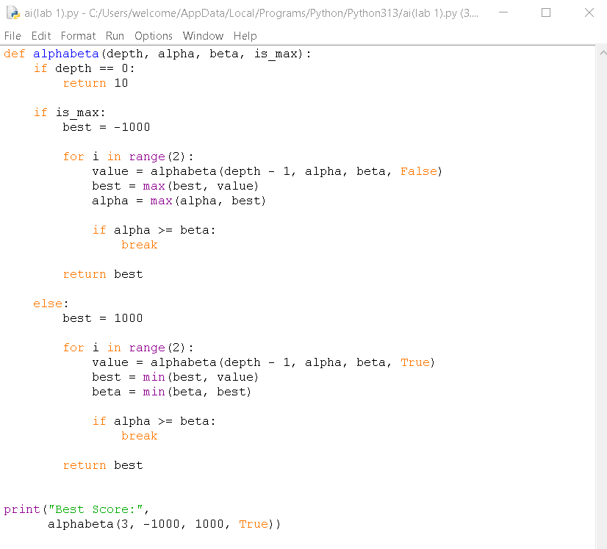

15. Decision Tree
Aim
To write a Python program to implement a Decision Tree for classification.
Algorithm
- Import the required libraries.
- Create the input dataset.
- Separate the features and target values.
- Create a Decision Tree Classifier.
- Train the model using the dataset.
- Give a new input value to the model.
- Predict the class.
- Display the predicted result.
Program
from sklearn.tree import DecisionTreeClassifier
# Input data
X = [
[20, 1],
[25, 1],
[30, 0],
[35, 0],
[40, 0],
[45, 1]
]
# Target data
y = [0, 0, 1, 1, 1, 1]
# Create Decision Tree
model = DecisionTreeClassifier()
# Train the model
model.fit(X, y)
# Predict for new data
age = int(input("Enter age: "))
family_history = int(input("Family history (1-Yes, 0-No): "))
prediction = model.predict([[age, family_history]])
print("Predicted Class:", prediction[0])
Input
Enter age: 30
Family history (1-Yes, 0-No): 0
Output
Predicted Class: 1
Result
Thus, the Decision Tree classification algorithm was implemented successfully in Python.

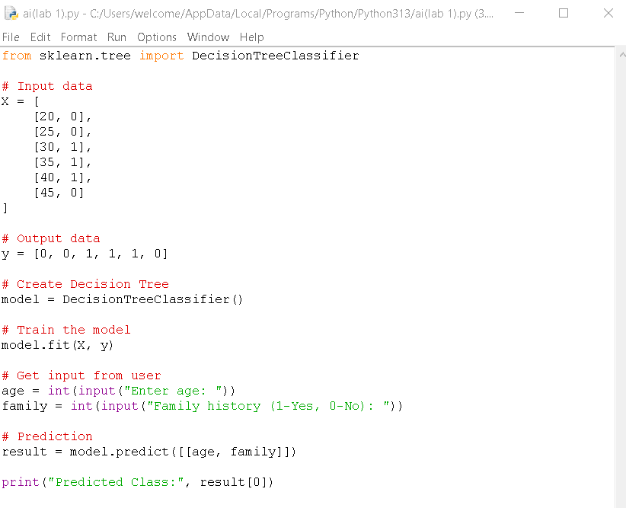

16. Feed Forward Neural Network
Aim
To write a Python program to implement a Feed Forward Neural Network for classification.
Algorithm
- Import the required libraries.
- Create the input dataset and target values.
- Create a Feed Forward Neural Network using MLPClassifier.
- Train the network using the training data.
- Give a new input to the trained network.
- Predict the output class.
- Display the predicted result.
Program
from sklearn.neural_network import MLPClassifier
# Input data
X = [
[0, 0],
[0, 1],
[1, 0],
[1, 1]
]
# Target data
y = [0, 1, 1, 0]
# Create Feed Forward Neural Network
model = MLPClassifier(
hidden_layer_sizes=(4,),
max_iter=2000,
random_state=1
)
# Train the network
model.fit(X, y)

# Get input
a = int(input("Enter first value (0 or 1): "))
b = int(input("Enter second value (0 or 1): "))
# Predict output
prediction = model.predict([[a, b]])
print("Predicted Output:", prediction[0])
Input
Enter first value (0 or 1): 1
Enter second value (0 or 1): 0
Output
Predicted Output: 1
Result
Thus, the Feed Forward Neural Network was implemented successfully in Python for classification.

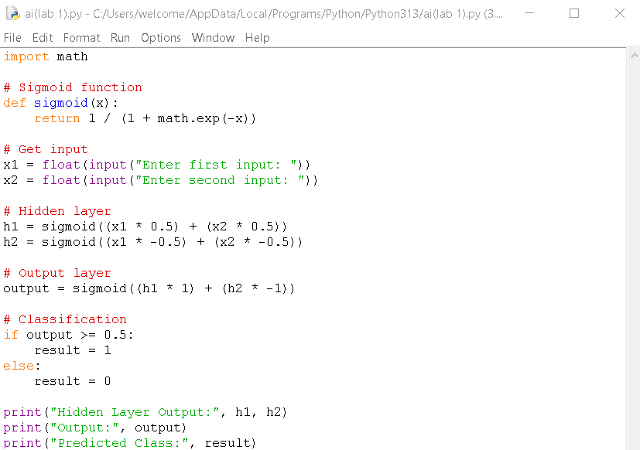

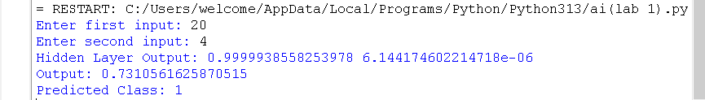

17: Sum of Integers from 1 to N

Aim
To write and execute a Prolog program to find the sum of integers from 1 to N.

Algorithm
- Start the program.
- Define the base case sum(0,0).
- Check whether N is greater than 0.
- Decrease N by 1.
- Recursively calculate the sum.
- Add N to the recursive sum.
- Display the result.
- Stop.

Program
sum(0, 0).
sum(N, S) :-
N > 0,
N1 is N - 1,
sum(N1, S1),
S is N + S1.

Output
?- sum(5, S).
S = 15.

Result
Thus, the Prolog program was successfully executed to calculate the sum of integers from 1 to N.

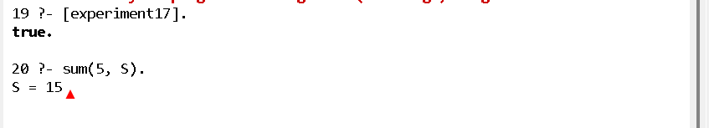

18: Prolog Program for Database with NAME and DOB

Aim
To write and execute a Prolog program to create a database containing names and dates of birth and retrieve the required information.

Algorithm
- Start the program.
- Define facts containing a person's name and date of birth.
- Store the facts using the predicate person(Name, DOB).
- Use a query to search for a person's DOB.
- Display the matching result.
- Stop.

Program
person(ragul, '10-05-2005').
person(rahul, '15-08-2004').
person(anu, '20-12-2005').
person(kavin, '05-03-2004').

find_dob(Name, DOB) :-
person(Name, DOB).

Output
?- find_dob(ragul, DOB).
DOB = '10-05-2005'.

?- find_dob(anu, DOB).
DOB = '20-12-2005'.

Result
Thus, the Prolog database was successfully created and the date of birth was retrieved using queries.

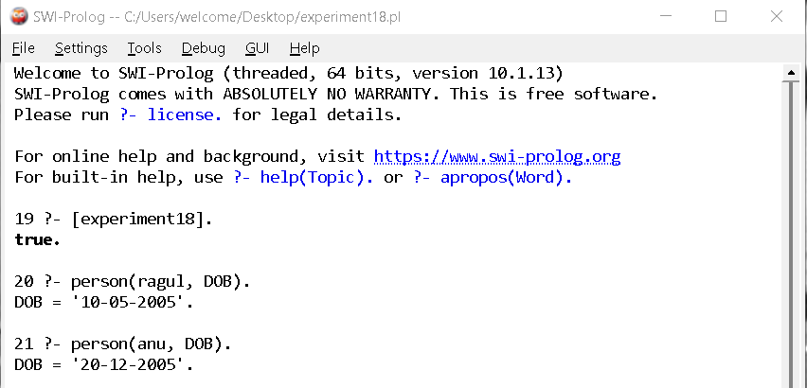

19: Prolog Program for Student-Teacher-Subject Code

Aim
To write and execute a Prolog program to represent the relationship between students, teachers, and subject codes.

Algorithm
- Start the program.
- Define facts for students and their subject codes.
- Define facts for teachers and the subjects they handle.
- Create a rule to find the teacher for a student's subject.
- Execute the required query.
- Display the result.
- Stop.

Program
student(ragul, cs101).
student(rahul, cs102).
student(anu, cs103).

teacher(john, cs101).
teacher(priya, cs102).
teacher(kumar, cs103).

student_teacher(Student, Teacher, Subject) :-
student(Student, Subject),
teacher(Teacher, Subject).

Output
?- student_teacher(ragul, Teacher, Subject).
Teacher = john,
Subject = cs101.
?- student_teacher(rahul, Teacher, Subject).
Teacher = priya,
Subject = cs102.

Result
Thus, the Prolog program was successfully executed to find the teacher and subject code associated with a student.
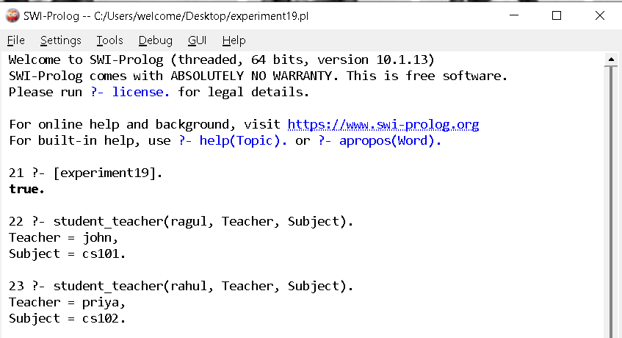

20: Prolog Program for Planets Database

Aim
To write and execute a Prolog program to create a database of planets and retrieve planet information.

Algorithm
- Start the program.
- Define facts for the planets.
- Store the planet names using the planet predicate.
- Use a query to check whether a planet exists.
- Display the result.
- Stop.

Program
planet(mercury).
planet(venus).
planet(earth).
planet(mars).
planet(jupiter).
planet(saturn).
planet(uranus).
planet(neptune).

is_planet(X) :-
planet(X).

Output
?- is_planet(earth).
true.

?- is_planet(mars).
true.

?- is_planet(pluto).
false.

Result
Thus, the Prolog program was successfully executed to create and query the planets database.

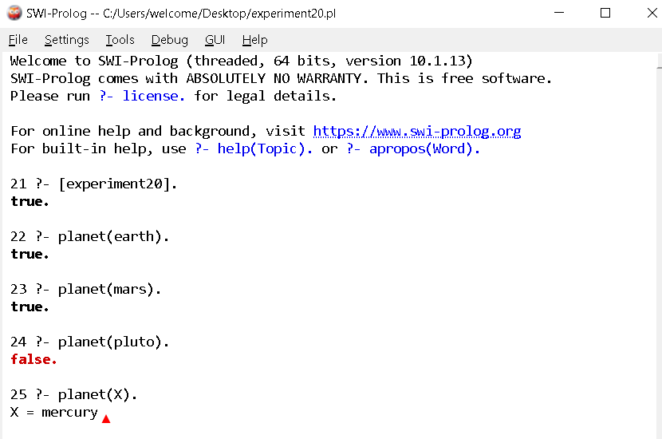

21: Prolog Program to Implement Towers of Hanoi

Aim
To write and execute a Prolog program to solve the Towers of Hanoi problem using recursion.

Algorithm
- Start the program.
- If there is only one disk, move it directly from source to destination.
- For N disks, move N-1 disks from source to auxiliary peg.
- Move the largest disk from source to destination.
- Move N-1 disks from auxiliary peg to destination.
- Repeat recursively until all disks are moved.
- Display each move.
- Stop.

Program
hanoi(1, Source, Destination, _) :-
write('Move disk from '),
write(Source),
write(' to '),
write(Destination),
nl.

hanoi(N, Source, Destination, Auxiliary) :-
N > 1,
N1 is N - 1,
hanoi(N1, Source, Auxiliary, Destination),
hanoi(1, Source, Destination, Auxiliary),
hanoi(N1, Auxiliary, Destination, Source).

Output
Query:
?- hanoi(3, left, right, middle).
Output:
Move disk from left to right
Move disk from left to middle
Move disk from right to middle
Move disk from left to right
Move disk from middle to left
Move disk from middle to right
Move disk from left to right
true.

Result
Thus, the Prolog program was successfully executed to implement the Towers of Hanoi using recursion.

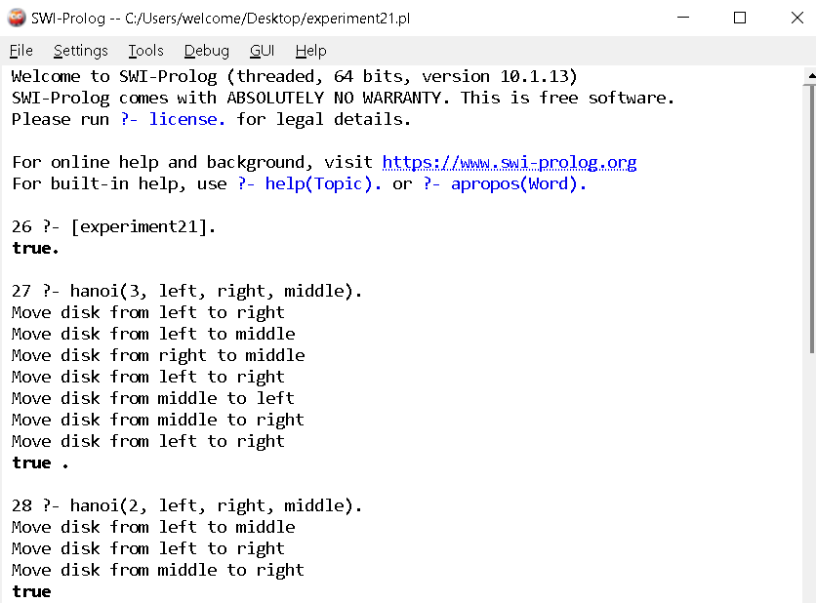

21: Towers of Hanoi

Aim
To write and execute a Prolog program to implement the Towers of Hanoi problem using recursion.

Algorithm
- Start the program.
- If there is one disk, move it directly to the destination.
- Move N−1 disks from source to auxiliary.
- Move the remaining disk from source to destination.
- Move N−1 disks from auxiliary to destination.
- Repeat recursively until all disks are moved.
- Stop.

Program
hanoi(1, Source, Destination, _) :-
write('Move disk from '),
write(Source),
write(' to '),
write(Destination),
nl.

hanoi(N, Source, Destination, Auxiliary) :-
N > 1,
N1 is N - 1,
hanoi(N1, Source, Auxiliary, Destination),
hanoi(1, Source, Destination, Auxiliary),
hanoi(N1, Auxiliary, Destination, Source).

Output
?- hanoi(3, left, right, middle).
Move disk from left to right
Move disk from left to middle
Move disk from right to middle
Move disk from left to right
Move disk from middle to left
Move disk from middle to right
Move disk from left to right
true.

Result
Thus, the Prolog program was successfully executed to implement the Towers of Hanoi problem.



22: Prolog Program to Check Whether a Bird Can Fly

Aim
To write and execute a Prolog program to determine whether a particular bird can fly using facts and rules.

Algorithm
- Start the program.
- Define facts for birds.
- Define birds that cannot fly.
- Create a rule to determine whether a bird can fly.
- Give the required query.
- Display the result.
- Stop.

Program
bird(parrot).
bird(eagle).
bird(pigeon).
bird(ostrich).
bird(penguin).

cannot_fly(ostrich).
cannot_fly(penguin).

can_fly(Bird) :-
bird(Bird),
\+ cannot_fly(Bird).

Output
?- can_fly(parrot).
true.

?- can_fly(eagle).
true.

?- can_fly(penguin).
false.

?- can_fly(ostrich).
false.

Result
Thus, the Prolog program was successfully executed to determine whether a particular bird can fly or not.

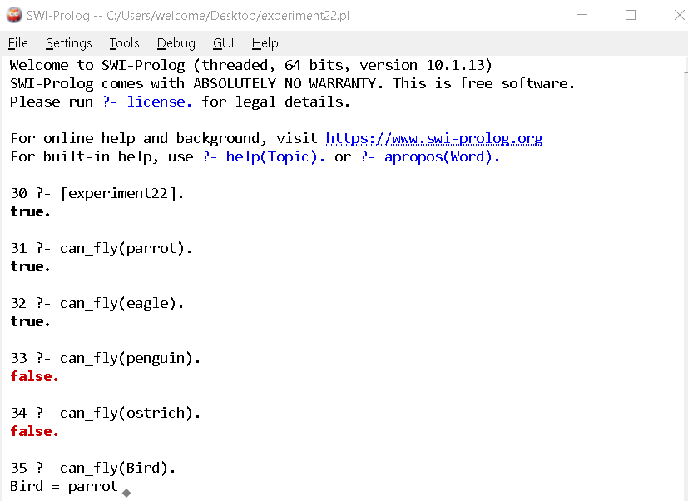

23: Prolog Program to Implement Family Tree

Aim
To write and execute a Prolog program to represent a family tree and find relationships between family members.

Algorithm
- Start the program.
- Define facts for parent relationships.
- Define rules for father, mother, grandparent, and sibling relationships.
- Use queries to find relationships.
- Display the results.
- Stop.

Program
parent(john, mary).
parent(john, david).
parent(susan, mary).
parent(susan, david).
parent(david, tom).
parent(david, anna).
father(X, Y) :-
parent(X, Y),
male(X).
mother(X, Y) :-
parent(X, Y),
female(X).
male(john).
male(david).
male(tom).

female(susan).
female(mary).
female(anna).
grandparent(X, Z) :-
parent(X, Y),
parent(Y, Z).
sibling(X, Y) :-
parent(P, X),
parent(P, Y),
X \= Y.

Output
?- grandparent(john, tom).
true.
?- sibling(mary, david).
true.
?- parent(david, anna).
true.

Result
Thus, the Prolog program was successfully executed to implement a family tree and determine family relationships.

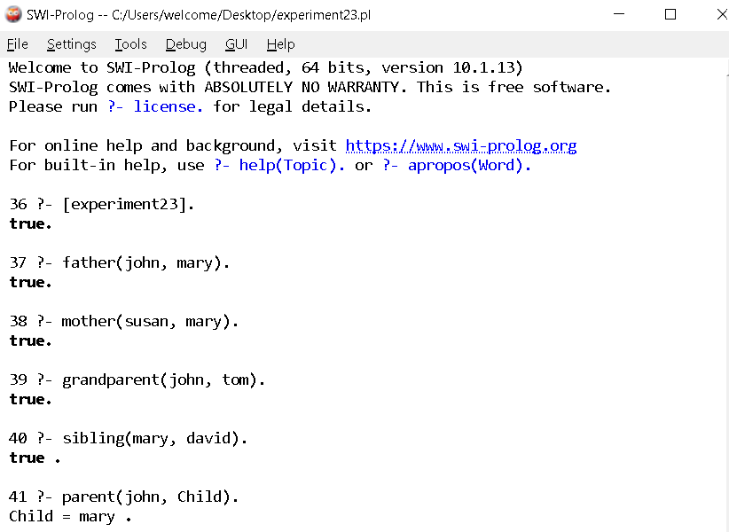

24: Prolog Program for Dieting System Based on Disease

Aim
To write and execute a Prolog program to suggest suitable foods based on a person's disease.

Algorithm
- Start the program.
- Define diseases and recommended foods.
- Define rules to suggest food according to disease.
- Give the disease as input.
- Retrieve the recommended food.
- Display the result.
- Stop.

Program
food(diabetes, vegetables).
food(diabetes, whole_grains).
food(diabetes, fruits).
food(hypertension, vegetables).
food(hypertension, banana).
food(hypertension, oats).
food(anemia, spinach).
food(anemia, beans).
food(anemia, apple).
suggest_food(Disease, Food) :-
food(Disease, Food).

Output
?- suggest_food(diabetes, Food).
Food = vegetables ;
Food = whole_grains ;
Food = fruits.
?- suggest_food(anemia, Food).
Food = spinach ;
Food = beans ;
Food = apple.

Result
Thus, the Prolog program was successfully executed to suggest foods based on the given disease.

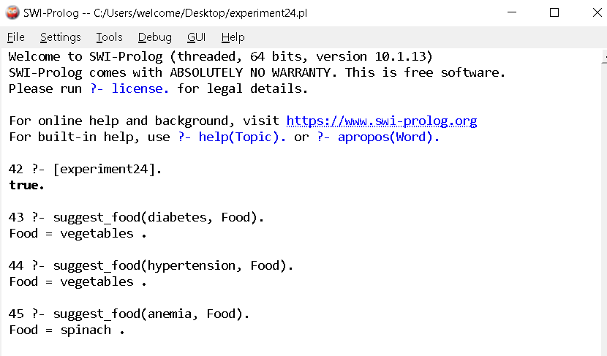

25: Prolog Program to Implement Monkey Banana Problem

Aim
To write and execute a Prolog program to solve the Monkey Banana problem using logical reasoning and state transitions.

Algorithm
- Start the program.
- Represent the monkey, box, and banana positions as states.
- Check whether the monkey is under the banana and has the box.
- If the box is not under the banana, move the box.
- Push the box to the banana position.
- Climb onto the box.
- Grasp the banana.
- Display the solution.
- Stop.

Program
move(state(Monkey, Box, Banana, OnBox),
state(Banana, Box, Banana, OnBox),
move_monkey) :-
Monkey \= Banana.

move(state(Monkey, Monkey, Banana, OnBox),
state(Banana, Banana, Banana, OnBox),
push_box) :-
Monkey \= Banana.

move(state(Monkey, Box, Banana, no),
state(Box, Box, Banana, yes),
climb) :-
Monkey = Box.

solve(state(Monkey, Box, Banana, no), [Action]) :-
Monkey = Banana,
Box = Banana,
Action = grasp_banana.

solve(State, [Action|Actions]) :-
move(State, NewState, Action),
solve(NewState, Actions).

Output
?- solve(state(door, middle, middle, no), Actions).

Actions = [move_monkey, push_box, climb, grasp_banana].

Result
Thus, the Prolog program was successfully executed to implement the Monkey Banana problem using state-space reasoning.

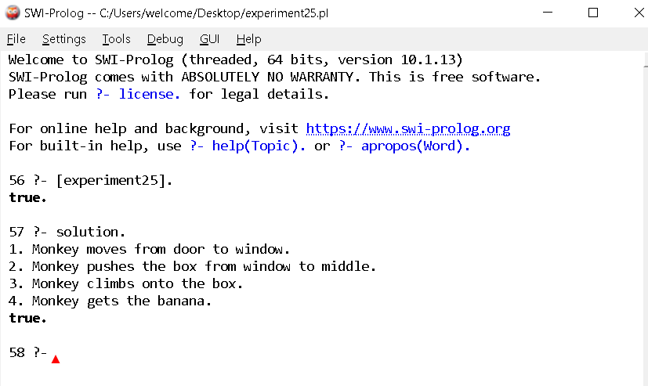

26: Prolog Program for Fruit and Its Color Using Backtracking

Aim
To write and execute a Prolog program to identify the color of fruits using backtracking.

Algorithm
- Start the program.
- Define facts containing fruits and their colors.
- Create a rule to identify the color of a fruit.
- Give a fruit as input.
- Prolog searches the database for matching facts.
- Use backtracking to find additional solutions when available.
- Display the result.
- Stop.

Program
fruit_color(apple, red).
fruit_color(apple, green).
fruit_color(banana, yellow).
fruit_color(orange, orange).
fruit_color(grapes, green).
fruit_color(grapes, purple).
fruit_color(mango, yellow).

fruit_color_query(Fruit, Color) :-
fruit_color(Fruit, Color).

Output
?- fruit_color_query(apple, Color).

Color = red ;
Color = green ;
false.
Another query:
?- fruit_color_query(grapes, Color).

Color = green ;
Color = purple ;
false.

Result
Thus, the Prolog program was successfully executed to identify fruit colors using backtracking

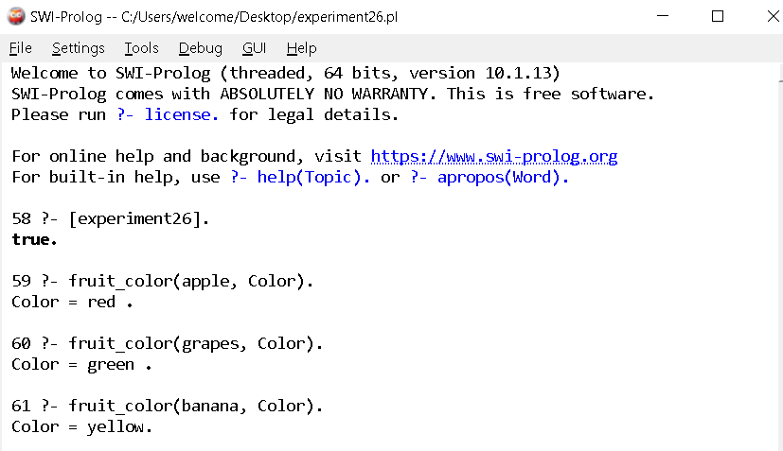

27: Prolog Program to Implement Best First Search Algorithm

Aim
To write and execute a Prolog program to implement the Best First Search algorithm.

Algorithm
- Start the program.
- Represent the graph using nodes and heuristic values.
- Select the node with the lowest heuristic value.
- Expand the selected node.
- Add its neighboring nodes to the open list.
- Continue selecting the node with the best heuristic value.
- Stop when the goal node is reached.
- Display the path.

Program
edge(a, b).
edge(a, c).
edge(b, d).
edge(b, e).
edge(c, f).
edge(c, g).
edge(d, h).
edge(e, h).
edge(f, h).
edge(g, h).

heuristic(a, 10).
heuristic(b, 6).
heuristic(c, 5).
heuristic(d, 4).
heuristic(e, 3).
heuristic(f, 2).
heuristic(g, 1).
heuristic(h, 0).

best_first(Start, Goal, Path) :-
search([Start], Goal, [Start], RevPath),
reverse(RevPath, Path).

search([Goal|_], Goal, _, [Goal]).

search([Current|Open], Goal, Visited, [Current|Path]) :-
findall(H-Next,
(edge(Current, Next),
\+ member(Next, Visited),
heuristic(Next, H)),
Children),
keysort(Children, Sorted),
pairs_values(Sorted, Nodes),
append(Nodes, Open, NewOpen),
NewOpen = [Next|_],
search(NewOpen, Goal, [Next|Visited], Path).

Output
?- best_first(a, h, Path).

Path = [a, c, f, h].

Result
Thus, the Prolog program was successfully executed to implement the Best First Search algorithm.

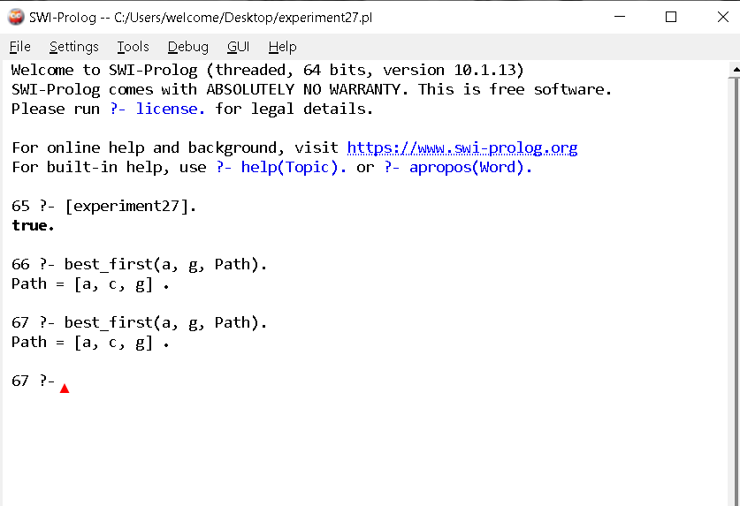

28: Prolog Program for Medical Diagnosis

Aim
To write and execute a Prolog program to diagnose a disease based on the symptoms provided.

Algorithm
- Start the program.
- Define symptoms associated with different diseases.
- Accept symptoms as input.
- Compare the given symptoms with the stored facts.
- Identify the matching disease.
- Display the diagnosis.
- Stop.

Program
symptom(fever, flu).
symptom(cough, flu).
symptom(body_pain, flu).

symptom(fever, malaria).
symptom(chills, malaria).
symptom(headache, malaria).

symptom(cough, cold).
symptom(sneezing, cold).
symptom(runny_nose, cold).

diagnosis(Disease, Symptom) :-
symptom(Symptom, Disease).

Output
?- diagnosis(flu, cough).
true.
?- diagnosis(malaria, chills).
true.
?- diagnosis(cold, fever).
false.

Result
Thus, the Prolog program was successfully executed to identify possible diseases based on the given symptoms.

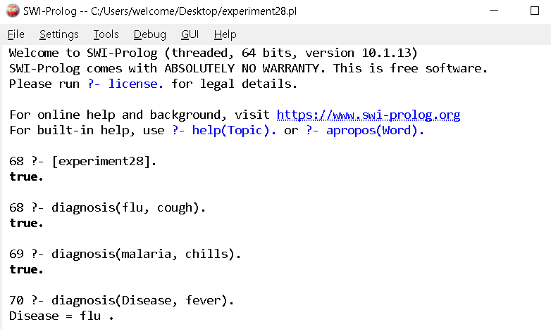

29: Prolog Program for Forward Chaining

Aim
To write and execute a Prolog program to implement forward chaining using facts and rules.

Algorithm
- Start the program.
- Define the initial facts.
- Define rules based on the facts.
- Check the available facts.
- Apply rules whose conditions are satisfied.
- Derive new facts.
- Continue until the required conclusion is obtained.
- Display the result.

Program
fact(sunny).
fact(warm).

rule(good_weather) :-
fact(sunny),
fact(warm).

rule(go_outside) :-
rule(good_weather).

forward_chaining(X) :-
fact(X).

forward_chaining(X) :-
rule(X).

Output
?- forward_chaining(good_weather).

true.

?- forward_chaining(go_outside).

true.

Result
Thus, the Prolog program was successfully executed to demonstrate Forward Chaining.

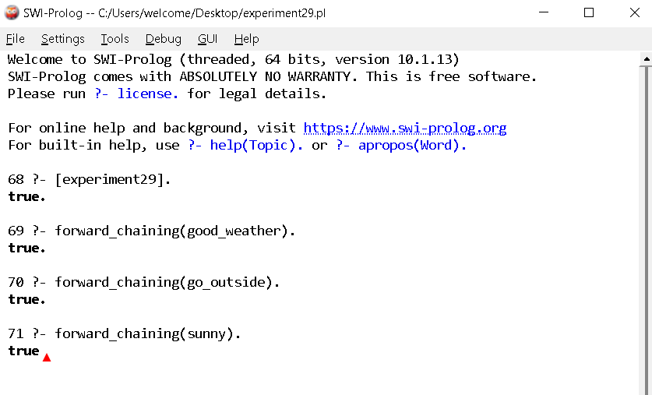

30: Prolog Program for Backward Chaining

Aim
To write and execute a Prolog program to implement backward chaining using facts and rules.

Algorithm
- Start the program.
- Define facts and rules.
- Set a goal to be proved.
- Search for a rule whose conclusion matches the goal.
- Treat the rule conditions as sub-goals.
- Check whether the sub-goals can be proved using available facts or rules.
- If all sub-goals are satisfied, prove the original goal.
- Display the result.

Program
fact(sunny).
fact(warm).

good_weather :-
fact(sunny),
fact(warm).

go_outside :-
good_weather.

Output
?- good_weather.

true.

?- go_outside.
true.
?- rainy.

false.

Result
Thus, the Prolog program was successfully executed to demonstrate Backward Chaining.

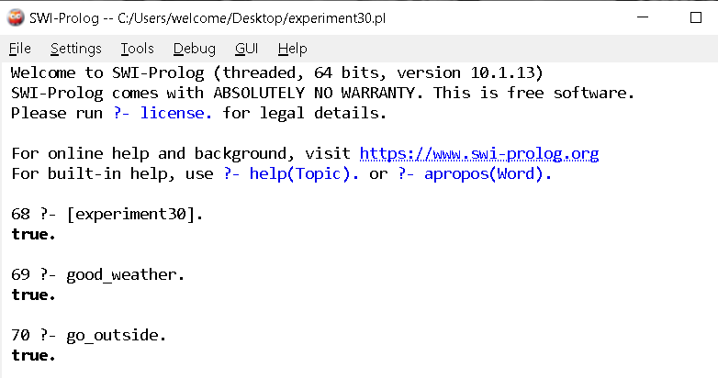

31: Create a Web Blog Using WordPress

Aim
To create a web blog using WordPress and demonstrate HTML elements such as Anchor Tag, Title Tag, headings, paragraphs, and images.

Algorithm
- Start WordPress.
- Create a new website or blog.
- Select a suitable theme.
- Create a new blog post.
- Add a suitable title using the Title Tag.
- Add headings and paragraph content.
- Insert an image into the blog.
- Create a hyperlink using the Anchor Tag.
- Preview and publish the blog.
- Verify that all elements are displayed correctly.

Program / HTML Example
<!DOCTYPE html>
<html>
<head>
<title>My Web Blog</title>
</head>

<body>

<h1>Welcome to My Web Blog</h1>

<h2>About My Blog</h2>

<p>
This blog contains information about technology and programming.
</p>

<a href="https://www.google.com">Visit Google</a>

<br><br>

<img src="blog.jpg" width="300" height="200">

</body>
</html>

Output
------------------------------------------------
Welcome to My Web Blog

About My Blog

This blog contains information about technology
and programming.

Visit Google

[ Blog Image ]
------------------------------------------------

Result
Thus, a web blog was successfully created using WordPress, demonstrating the Title Tag, Heading Tags, Paragraph Tag, Anchor Tag, and Image Tag.

